### **Output Layer of a Multi-Class Classification Problem**

Deciding the output layer

1. The Output Activation function is chosen depending on the task at hand (can be a softmax, linear etc)
2. Consider the following multi-class classification problem
3. At the last layer, we compute a3 = W3h2 + b3
4. We need to apply a function to ŷi = O(a3i) such that the 4 outputs form a probability distribution.
5. Output activation function has to be chosen such that the output is probability.
6. Let’s assume a3 = [3 4 10 3]
   1. Take each entry and divide by the sum of all entries to get a probability distribution
 $\hat{y_{1}}= \frac{3}{(3+4+10+3)} = 0.15$

 $\hat{y_{2}}= \frac{4}{(3+4+10+3)} = 0.20$

 $\hat{y_{3}}= \frac{10}{(3+4+10+3)} = 0.50$

$\hat{y_{4}}= \frac{3}{(3+4+10+3)} = 0.15$

2. However, **this will not work** if any of the entries are negative
7. So we consider the softmax function
8. $softmax(z_{i}) = \frac{e^{z_{i}}}{{Σ^{k}}_{j=1}e^{z_{j}}}$ for i = 1...k
9. Note: the output of ex is always positive, irrespective of the input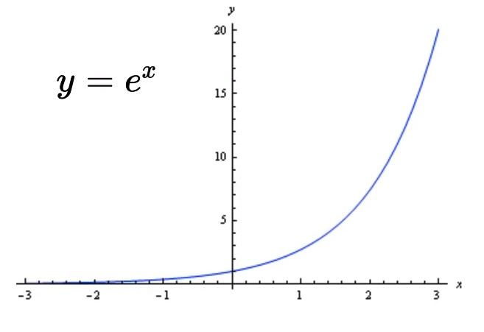
10. This property is important to counter the negative-value shortcoming that we observed in the previous example
11. Now, let us illustrate the softmax function at the last layer of our Neural Network
$a = [a_{1} a_{2} a_{3} a_{4}]$

$softmax(a) = [\frac{e^{a_{1}}}{{Σ^{k}}_{j=1}e^{a_{j}}} \frac{e^{a_{2}}}{{Σ^{k}}_{j=1}e^{a_{j}}} \frac{e^{a_{3}}}{{Σ^{k}}_{j=1}e^{a_{j}}} \frac{e^{a_{4}}}{{Σ^{k}}_{j=1}e^{a_{j}}}]$

12. Raising the numerators to ex ensures that they are all positive
13. The denominator is just the sum of all the values raised to ex
14. So for our multi-class fruit classifier, the equations are as follows

|  |  |  |
| --- | --- | --- |
| **Layer** | **Pre-activation** | **Activation/Output** |
| Hidden Layer 1 | $a_{1}= W_{1}*x + b_{1}$ | $h_{1}= g(a_{1})$ |
| Hidden Layer 2 | $a_{2}= W_{2}*h_{1} + b_{2}$ | $h_{2}= g(a_{2})$ |
| Output Layer | $a_{3}= W_{3}*h_{2} + b_{3}$ | $\hat{y}= softmax(a_{3})$ |